**Tours And Travels Company Management**

**DBMS FA-4**

***Student***

*of*

**Bachelor of Technology**

in

**Computer Science & Engineering**



**Chitkara University Institute of Engineering and Technology**

**Year (2020 -2024)**

**Tours And Travels Company Management**

**Description of the project:**

The Tours and Travel Management System is a database-based application. The main purpose of “Tours and travels management system” is to provide a convenient way for a customer to book hotels, flight, train and bus for tour purposes. The objective of this project is to develop a system that automates the processes and activities of a travel agency. In this project, we will make an easier task of searching places and for booking train, flight or bus.

The project is to build up a framework that can automate the processes and tasks of travel service in a simple way. This Web Application gives new Packages at an adaptable cost with the goal that clients can reserve without any problem. As per season Admin can change packages, User Management, Customer information, Room Details, Currency subtleties, Room Booking details, Tax details, Reports like Customer Details, Booking Report, Payment Report, Reserved Rooms, Print Invoice, Paid/Unpaid Reservations. And because of these reports, we can find any record at any time without any difficulty. Tours and Travels Project is planned in Oracle Database.  
  
This software of ' **Online tourism management system project** is created to supplant the presently existing framework, which helps in keeping travel details of the customer, details of places as It spares the significant resource that is time, alongside exactness, unwavering quality, and consistency can be kept up. This task is advantageous for the administrator of the business as it causes them to look through the data quicker than the current framework, to discover client records promptly and report of the client installments, and so on are created according to necessity.

The goal of this project is to build up a framework that can automate the processes and tasks of travel service in a simple way. This Web Application gives new Packages at an adaptable cost with the goal that clients can reserve without any problem. As per season Admin can change packages, User Management, Customer information, Room Details, Currency subtleties, Room Booking details, Tax details, Reports like Customer Details, Booking Report, Payment Report, Reserved Rooms, Print Invoice, Paid/Unpaid Reservations. And because of these reports, we can find any record at any time without any difficulty. Tours and Travels Project is planned in PHP programming language, just as the MYSQL server utilized for this specific site.  
  
This software of ' **Online tourism management system project in php source code**' is created to supplant the presently existing framework, which helps in keeping travel details of the customer, details of places as It spares the significant resource that is time, alongside exactness, unwavering quality, and consistency can be kept up. This task is advantageous for the administrator of the business as it causes them to look through the data quicker than the current framework, to discover client records promptly and report of the client installments, and so on are created according to necessity.

**ER Diagram**

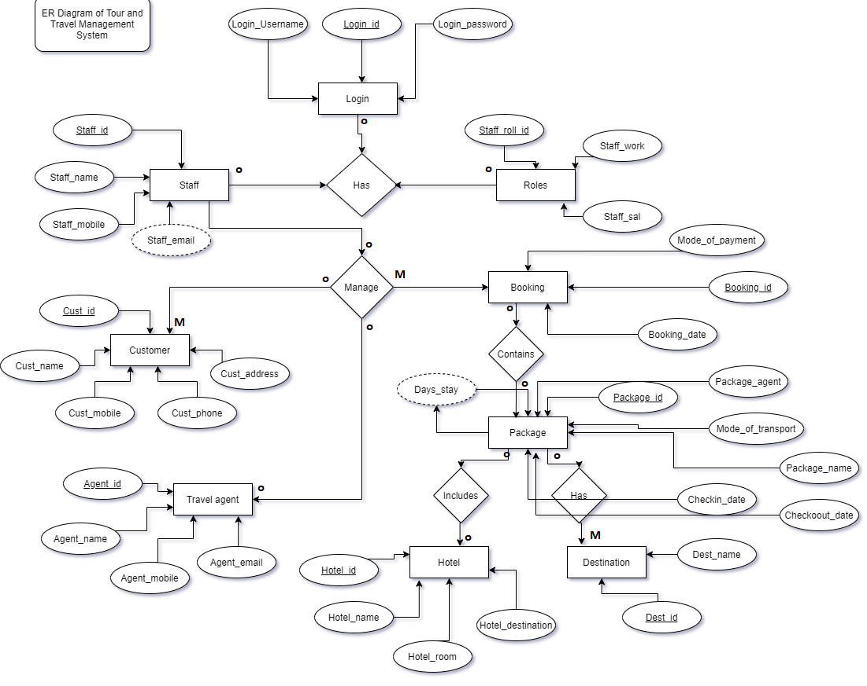

This ER diagram represents the model of tours and travel management system entity.

The ER diagram shows all the visual instrument of database tables and the relations between Transportation, Hotel, Package, Customers etc. It uses structure data to define the relationship between data group functionality. The main entities of the Tours and Travel management system are Package, Transportation, Booking, Hotel and Customer.

**Database**.

In our database we have 10 tables after normalization,

**Destination:** the table includes all the information about the destinations where the company may want to offer the package. The table includes details like destination id, country etc.

**Destination** (Dest_id, Dest_Name, Dest_country)

Here the primary key is Dest_id.

**Hotels:** the table includes all the information about the Hotels, the name and place where the user can find them.

**Hotel**(hot_id, hot_name, hot_destination)

Here, the primary key is Hot_id.

**Customer:** The table contains all the information of the customers. The time when someone registers itself to be the part of the company, the data gets store very easily in the table. The customer registered in the table only can book packages from the company.

**Customer** (cust_id, cust_name, cust_email, cust_phone, cust_address)

Here the primary key is cust_id.

**Travel Agents:** Any tours and travel agency must be having some travel agents in order to get the deals. This very table stores the info about all the travel agent the company is partnered with.

**Travel_Agent** ( agent_id, agent_name, agent_phone, agent_email)

Here, the primary key id agent_id.

**Package:** The company loves to give packages. A package is a combination of destination, hotel, food all in the cost. The company gives exciting packages to the users to attract them. Hence the package table in our database, would store the information of all the packages with the collection of hotels and destination.

**Package** (pkg_id, pkg_name, pkg_amount, dest_id, days, checkin_Date, checkout_date, hotel_id, Mode_of_transportation)

Here, the primary key is pkg_id

And the foreign keys are Hotel_id and Destination_id

**Booking:** since the customers need to book a certain package. We have made the booking table. Here the customer data along with the package that they had chosen would be registered. The booking table also includes the date when the packages are booked.

**Booking** (booking_id, Date, package_id, customer_id, Phone_no, address, Mode_of_payment)

Here, the primary key is booking_id

And the foreign key is package_id, Customer_id;

**Staff:** the table is designed to manage the staff details. Includes information about the staff like roles, name etc.

**Staff** (Staff_Id, Staff_name, Staff_mobile, Staff_email, Sroll_id)

The primary key is Staff_id

And the foreign key is Sroll_id

**Roles:** the table contain the role of different staff members.

**Roles** (Sroll_id, Staff_job, Staff_sal)

The primary key is Sroll_id

**Login:** the table has all the login details like username, password.

**Login** (login_id, password, username)

It has only foreign key that is login_id.

**givesPackage:** the tables have all the packages that the travel agent would handle.

**givesPackages** (agent, package)

it has two foreign keys that is agent, package.

**Code for the table:**

create table Destination(dest_id varchar(3) primary key, dest_name varchar(50), country char(40));

insert into destination values ('d1','Paris', 'France');

insert into destination values ('d2','Goa', 'India');

insert into destination values ('d3','London', 'England');

insert into destination values ('d4','Ladakh', 'India');

insert into destination values ('d5','Andaman & Nicobar', 'India');

insert into destination values ('d6','Jaipur', 'India');

insert into destination values ('d7','Hawaii', 'US');

insert into destination values ('d8','Italy', 'Italy');

insert into destination values ('d9','Kerala', 'India');

insert into destination values ('d10','Kashmir', 'India');

create table Customer(cust_Id varchar(5) primary key, cust_name varchar(20), cust_email varchar(30), cust_phone varchar(15), cust_address varchar(60));

insert into customer values ('c1','Sara' , 'sara123@gmail.com',9654238741,'#17 block D,Rohini,Delhi');

insert into customer values ('c2','Emma', 'emma45@rediffmail.com',8756412369,'M-17 Sector- 70, Noida');

insert into customer values ('c3','Chiranshu', 'chiranshjindal98@gamil.com',7854123695,'Sector-23,Chandigarh');

insert into customer values ('c4','Rajesh Garg','rajeshgarg1997@gmail.com',8456249756,'DLF Colony , Rohtak');

insert into customer values ('c5','Sahil','sahil612@gmail.com',7894236045,'C-3 Model Town, Gurugram');

insert into customer values ('c6','Rishav garg', 'Rishavgarg672@gmail.com',9835647594,'99, KD road, Jodhpur');

insert into customer values ('c7','shenaz virk', 'virkshenaz2@gmail.com',9835645294,'#159 ,Green Road, Mirzapur');

insert into customer values ('c8','Sushant Khurana', 'khurana236@gmail.com',9741647594,'Sector-12,Solan');

insert into customer values ('c9','Bhumika Narang', 'bhumikanarang@gmail.com',7065647594,' Bharat Nagar Chownk, Ludhiana');

insert into customer values ('c10','Varun Maan', 'maanvarun89@gmail.com',8535647594,'251 ,Sector 38A , Chandigarh');

create table Hotels(hot_id integer primary key, hot_Name varchar(50), destination varchar(25));

insert into Hotels values (101,'Tower Heights', 'Paris');

insert into Hotels values (102,'Golder Cherry', 'Goa');

insert into Hotels values (103,'Crowne Plaza', 'London');

insert into Hotels values (104,'Emerald Bay', 'Ladakh');

insert into Hotels values (105,'Sunset Lodge', 'Andaman & Nicobar');

insert into Hotels values (106,'Hotel Agoura', 'Jaipur');

insert into Hotels values (107,'The Manhattan', 'Hawaii');

insert into Hotels values (108,'Lime Wood', 'Italy');

insert into Hotels values (109,'Double Forest', 'Kerala');

insert into Hotels values (110,'Shershah Hotel', 'Kashmir');

create table StRoles(sroll_Id integer primary key, staff_Job char(30), staff_Sal integer);

insert into StRoles values (102000,'travel agent', 10000);

insert into StRoles values (102010, 'tour guide', 15000);

insert into StRoles values (102020,'travel agent', 12000);

insert into StRoles values (102030,'booking agent',8000);

insert into StRoles values (102040,'customer care', 5000 );

insert into StRoles values (102050,'tour guide', 15000);

insert into StRoles values (102060,'customer care', 8000 );

insert into StRoles values (102070,'receptionist',10000);

insert into StRoles values (102080, 'travel agent', 13000);

insert into StRoles values (102090,'travel agent' , 11000);

create table Staff(staff_Id integer primary key, staff_Name char(40), staff_mob char(15), staff_Email char(25), staff_r integer, foreign key(staff_r) references stRoles(sroll_Id));

insert into staff values (1001,'Alex', '6127946104' , 'alex@company.com', 102000);

insert into staff values (1002,'Michael', '6710748842' , 'michel@company.com', 102010);

insert into staff values (1003,'Jack', '7128930342' , 'jack@company.com', 102040);

insert into staff values (1004,'Anthony', '6740875470' , 'anthony@company.com', 102060);

insert into staff values (1005,'James', '6219973944' , 'james@company.com', 102050);

insert into staff values (1006,'Grace', '7286190475' , 'grace@company.com', 102070);

insert into staff values (1007,'Zoe', '8917405893' , 'zoe@company.com', 102080);

insert into staff values (1008,'Ivy', '6121990819' , 'ivy@company.com', 102020);

insert into staff values (1009,'Bella', '6120389224' , 'bella@company.com', 102030);

insert into staff values (1010,'Maria', '8847413994' , 'maria@company.com', 102090);

create table login(login_Id integer primary key, login_Name char(20), login_Password varchar(30), foreign key(login_id) references Staff(staff_Id));

insert into login values (1001,'Alex12', 'alex@4001');

insert into login values (1002,'Michael23', 'michel@4002');

insert into login values (1003,'Jack34', 'jack@4003');

insert into login values (1004,'Anthony45', 'anthony@4004');

insert into login values (1005,'James56', 'james@4005');

insert into login values (1006,'Grace67', 'grace@4006');

insert into login values (1007,'Zoe78', 'zoe@4007');

insert into login values (1008,'Ivy89', 'ivy@4008');

insert into login values (1009,'Bella90', 'bella@4009');

insert into login values (1010,'Maria01', 'maria@4010');

create table PackageC(pkg_id varchar(5) primary key, pkg_Name char(30), pkg_dest varchar(3), pkg_hotel integer, checkin_date date, checkout_date date, no_Days integer,

pkg_price integer, mode_of_transportation char(10), foreign key(pkg_dest) references Destination(dest_Id), foreign key(pkg_hotel) references Hotels(hot_id));

insert into PackageC values ('Pkg1','trip to paris','d1', 101,TO_DATE('1/1/2021', 'DD/MM/YYYY'), TO_DATE('6-Jan-2021', 'DD/MM/YYYY'), 6, 50000 ,'Flight');

insert into PackageC values ('Pkg2','trip to goa', 'd2', 102,TO_DATE('10/2/2021', 'DD/MM/YYYY'), TO_DATE('16/2/2021', 'DD/MM/YYYY'), 6, 20000 ,'Train');

insert into PackageC values ('Pkg3','trip to london','d3', 103,TO_DATE('1/3/2021', 'DD/MM/YYYY'), TO_DATE('6/3/2021', 'DD/MM/YYYY'), 6, 60000 ,'Flight');

insert into PackageC values ('Pkg4','trip to ladakh','d4', 104,TO_DATE('15/4/2021', 'DD/MM/YYYY'), TO_DATE('21/4/2021', 'DD/MM/YYYY'), 6, 30000 ,'Car');

insert into PackageC values ('Pkg5','trip to a&d','d5', 105,TO_DATE('1/5/2021', 'DD/MM/YYYY'), TO_DATE('16/5/2021', 'DD/MM/YYYY'), 16, 25000 ,'Flight');

insert into PackageC values ('Pkg10','trip to jaipur','d6', 106,TO_DATE('1/10/2021', 'DD/MM/YYYY'), TO_DATE('12/10/2021', 'DD/MM/YYYY'), 12, 30000,'Train');

insert into PackageC values ('Pkg6','trip to hawai','d7', 107,TO_DATE('1/6/2021', 'DD/MM/YYYY'), TO_DATE('20/6/2021', 'DD/MM/YYYY'),20 , 40000 ,'Flight');

insert into PackageC values ('Pkg7','trip to italy','d8', 108,TO_DATE('1/7/2021', 'DD/MM/YYYY'), TO_DATE('25/7/2021', 'DD/MM/YYYY'), 25, 70000 ,'Flight');

insert into PackageC values ('Pkg8','trip to kerela','d9', 109,TO_DATE('5/8/2021', 'DD/MM/YYYY'), TO_DATE('9/8/2021', 'DD/MM/YYYY'),4, 25000 ,'Car');

insert into PackageC values ('Pkg9','trip to kashmir','d10', 110,TO_DATE('25/9/2021', 'DD/MM/YYYY'), TO_DATE('1/10/2021', 'DD/MM/YYYY'),7, 20000 ,'Flight');

create table Travel_Agent(agent_Id integer primary key, agent_Name char(20), phone char(15), agent_Email varchar(50));

insert into travel_agent values (1001,'Alex', 6127946104 , 'alex@company.com');

insert into travel_agent values (1003,'Jack',7128930342 , 'jack@company.com');

insert into travel_agent values (1009,'Bella', 6120389224 , 'bella@company.com');

insert into travel_agent values (1010,'Maria', 8847413994 , 'maria@company.com');

create table Booking(book_Id integer primary key, book_Date date, customer varchar(5), package_Taken varchar(5), mode_of_payment char(20), foreign key(customer) references Customer(cust_Id), foreign key(package_Taken) references PackageC(pkg_id));

insert into Booking values(1001, TO_DATE('8/9/2021', 'DD/MM/YYYY'), 'c1', 'Pkg1', 'CASH');

insert into Booking values(1002, TO_DATE('24/8/2021', 'DD/MM/YYYY'), 'c2', 'Pkg2', 'DEBIT CARD');

insert into Booking values(1003, TO_DATE('26/12/2021', 'DD/MM/YYYY'), 'c3', 'Pkg3', 'CASH');

insert into Booking values(1004, TO_DATE('11/11/2021', 'DD/MM/YYYY'), 'c4', 'Pkg4', 'CASH');

insert into Booking values(1005, TO_DATE('10/7/2021', 'DD/MM/YYYY'), 'c5', 'Pkg5', 'DEBIT CARD');

insert into Booking values(1006, TO_DATE('9/1/2021', 'DD/MM/YYYY'), 'c6', 'Pkg6', 'CASH');

insert into Booking values(1007, TO_DATE('21/9/2021', 'DD/MM/YYYY'),'c7', 'Pkg7', 'NETBANKING');

insert into Booking values(1008, TO_DATE('30/4/2021', 'DD/MM/YYYY'), 'c8', 'Pkg8', 'CASH');

insert into Booking values(1009, TO_DATE('17/1/2021', 'DD/MM/YYYY'), 'c9', 'Pkg9', 'DEBIT CARD');

insert into Booking values(1010, TO_DATE('12/1/2021', 'DD/MM/YYYY'), 'c10', 'Pkg10', 'NETBANKING');

create table givesPackeges(travel_agent integer, packageGiven varchar(5), foreign key(travel_agent) references Travel_agent(agent_id), foreign key(packageGiven) references PackageC(pkg_id));

insert into givesPackeges values(1001, 'Pkg2');

insert into givesPackeges values(1003, 'Pkg10');

insert into givesPackeges values(1009, 'Pkg5');

insert into givesPackeges values(1010, 'Pkg3');

insert into givesPackeges values(1003, 'Pkg6');

insert into givesPackeges values(1001, 'Pkg7');

insert into givesPackeges values(1003, 'Pkg1');

insert into givesPackeges values(1009, 'Pkg9');

**CREATION OF TABLES:**

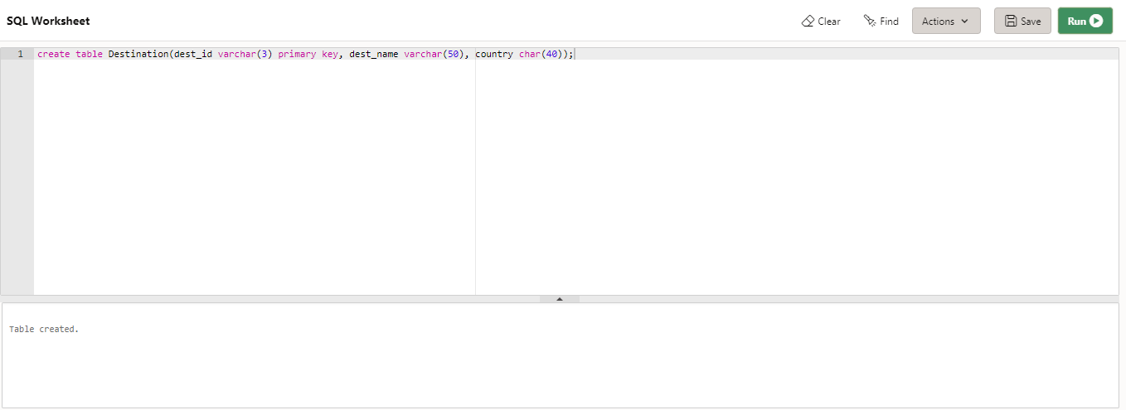

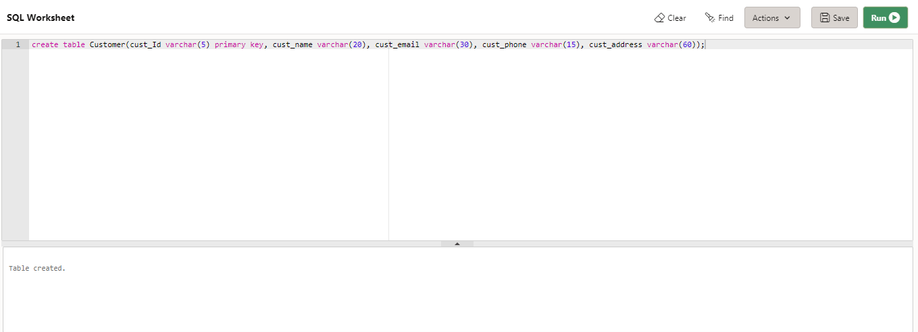

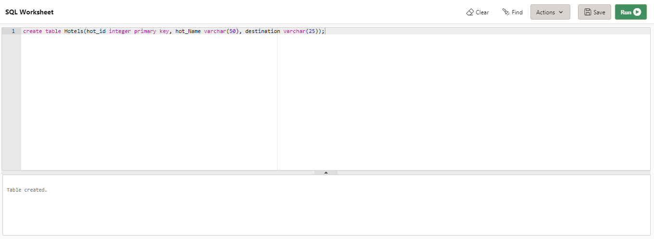

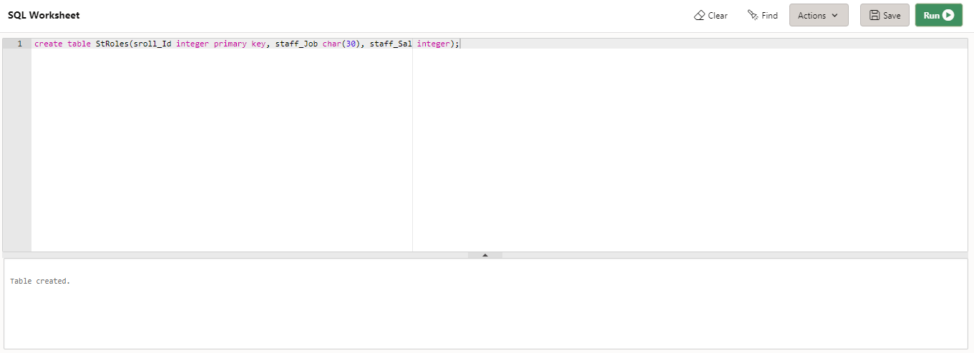

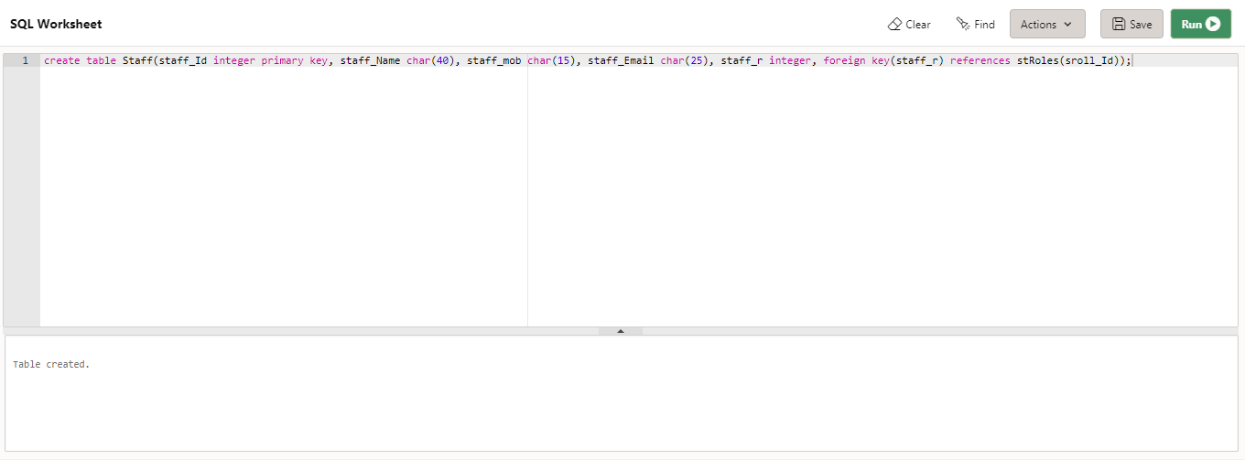

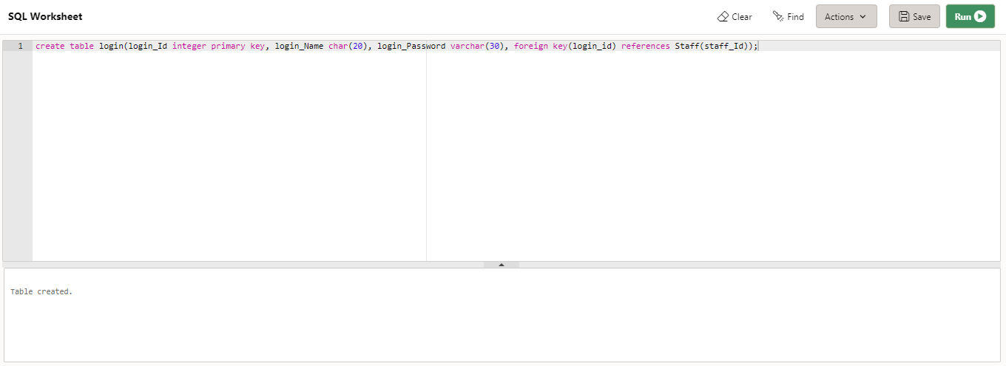

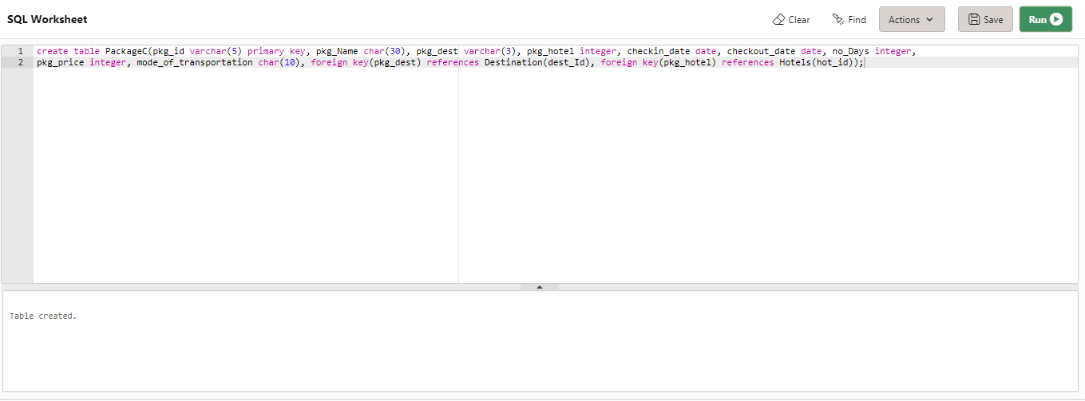

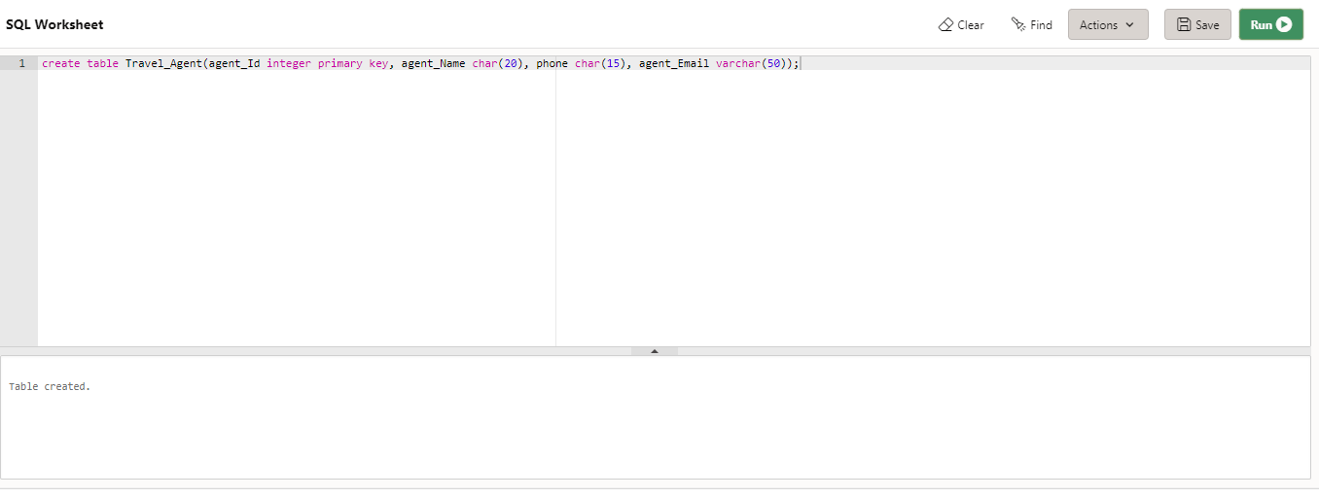

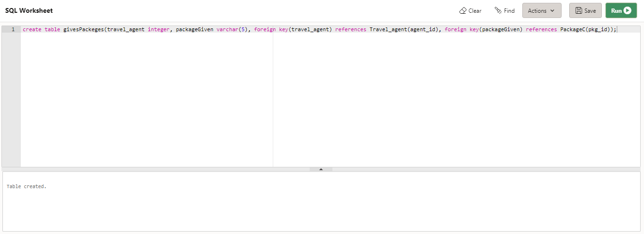

**INSERTION AND DISPLAYING OF TABLES:**

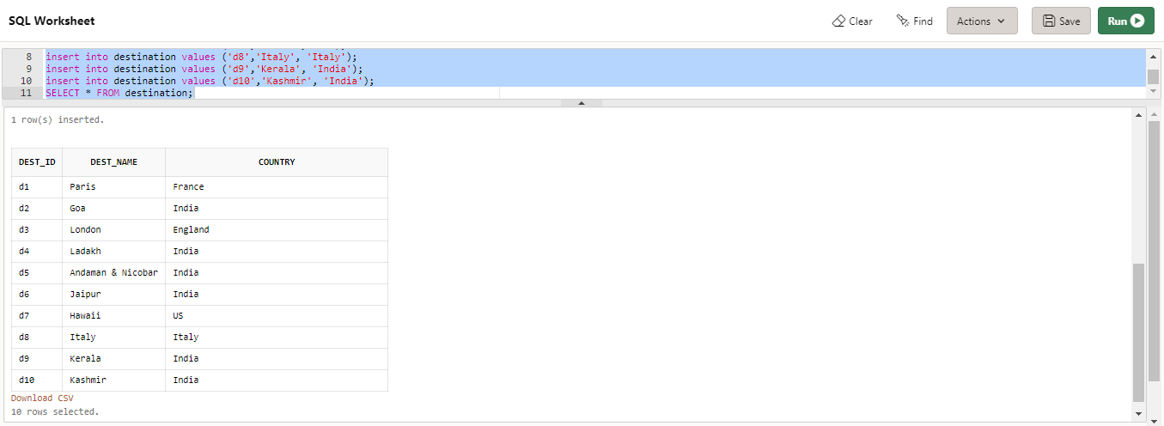

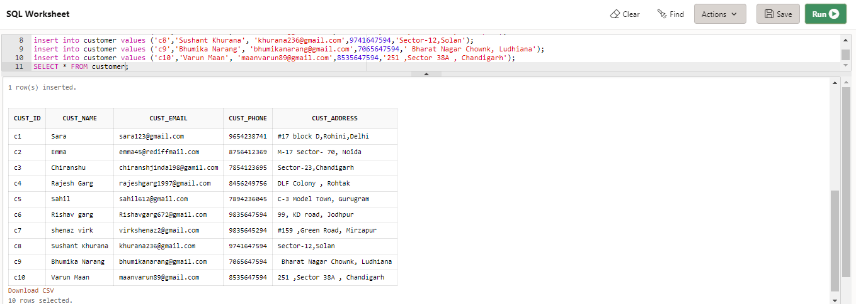

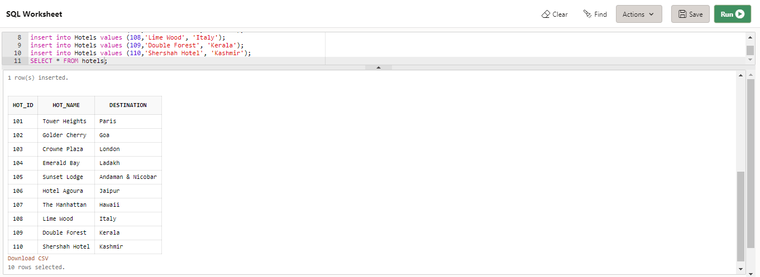

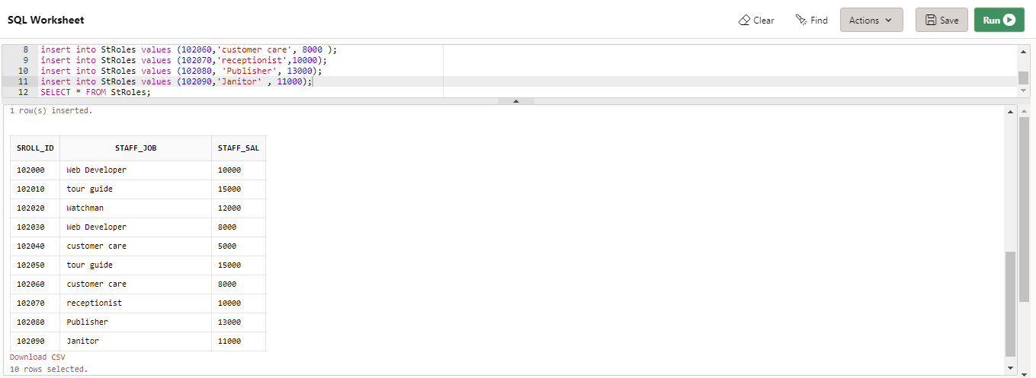

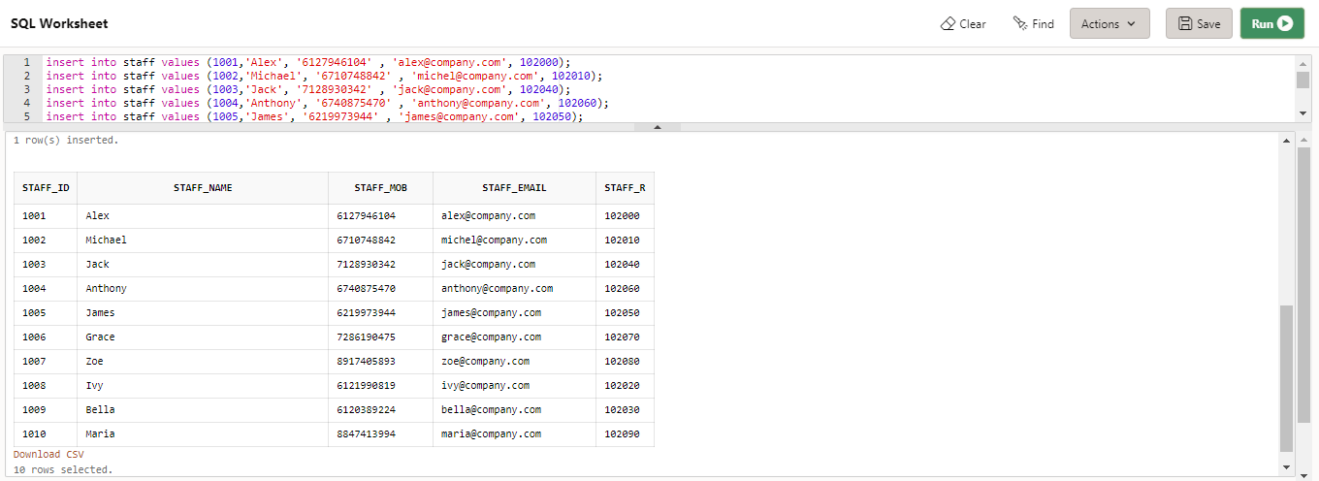

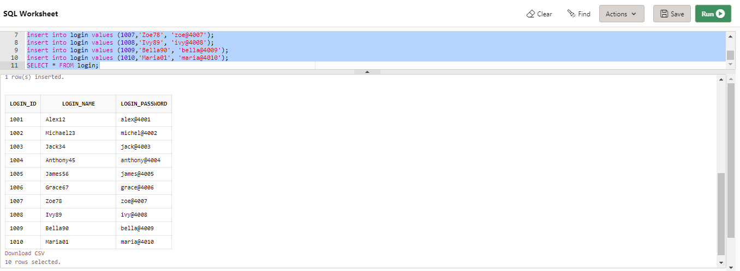

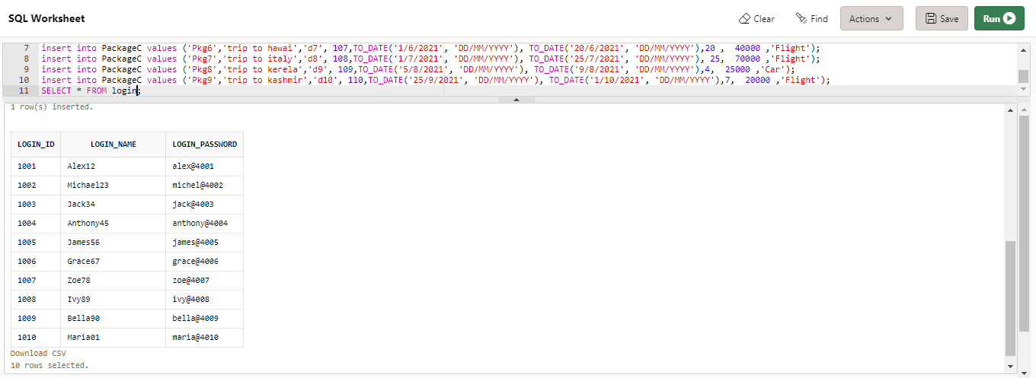

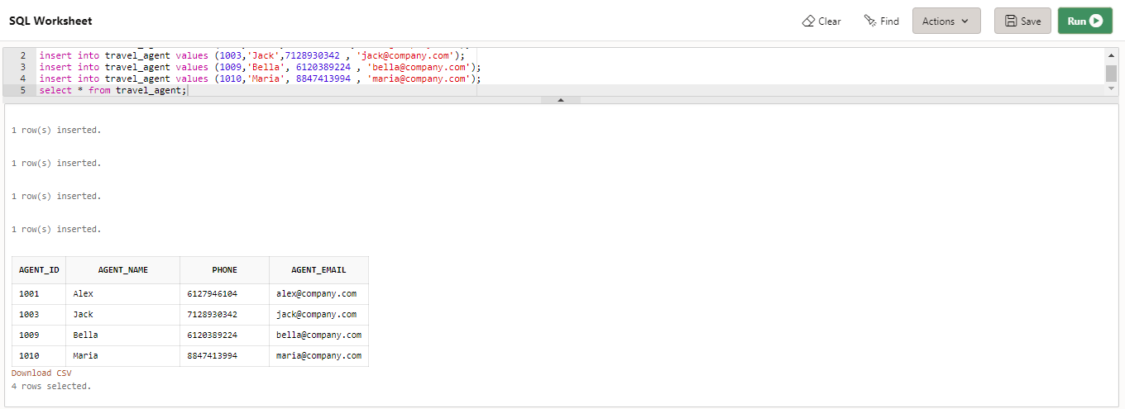

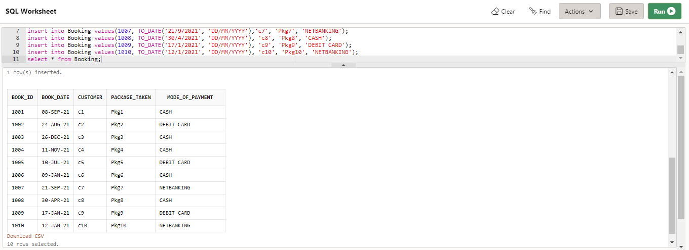

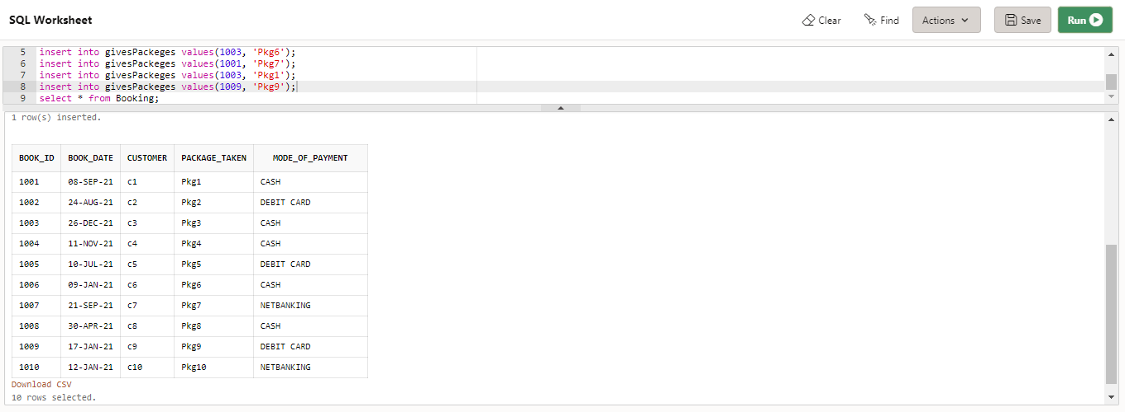

**Normalization**

So, we have 6 tables in our project.

1. Package (pkg_id, pkg_name, pkg_amt, dest_id, dest_name, dest_country, days checkin_date, checkout_date, hotel, mode_of_transportation)
2. Booking (booking_id, booking_date, cust_name, cust_email, cust_address, pkg, pay_method)
3. Travel Agent (agent_id, agent_name, phn, email, pkg_managing)
4. Staff (staff_id, staff_name, staff_mobile, staff_email, sroll_id, staff_job,staff_salary)
5. Login (login_id, password, username)
6. Hotel (hotel_id, hotel_name, hotel_address)

**NORMALIZING PACKAGE TABLE**

Package (pkg_id, pkg_name, pkg_amt, dest_id, dest_name, dest_country, days checkin_date, checkout_date, hotel, mode_of_transportation)

Since there is no multivalued attribute, hence the table is 1NF.

Now,

We don’t have any partial dependency, hence the table is in 2NF also.

But,

There is a transitive dependency i.e.

Pkg_id 🡪 pkg_name, pkg_amt, dest_id, dest_name,dest_country, days checkin_date, checkout_date, hotel, mode_of_transportation

And dest_id 🡪 dest_name

Hence, we need to decompose the two tables as:

Package (pkg_id, pkg_name, days, checkin_date, checkout_date, hotel, mode_of_transportation, dest_id) and,

Destination (dest_id, dest_name, dest_country)

Also,

The tables in the BCNF as there is only one super key in both the tables.

**NORMALIZING BOOKING TABLE**

Booking (booking_id, booking_date, cust_id, cust_name, cust_email, cust_address, pkg, pay_method)

Since there are atomic values, i.e., there are no multivalued attributes, hence we can say that that the table is in 1NF.

Now,

We also don’t see any partial dependency in the table, so we can say that the table is in 2NF also.

But,

We have a transitive dependency in the table:

Booking_id 🡪booking_id, booking_date, cust_id, cust_name, cust_email, cust_address, pkg, pay_method

Cust_id 🡪 cust_id, cust_name, cust_email, cust_address

Hence, we may want to decompose the tables as:

Booking (booking_id, booking_date, , cust_id, pkg, pay_method)

Customer (cust_id, cust_name, cust_email, cust_address)

Also,

The tables are in BCNF as there is only one key determining all the attributes in the tables.

**NORMALIZING THE TRAVEL AGENT TABLE**

Travel Agent (agent_id, agent_name, phn, email, pkg_managing)

Here in this table, we can see that the table is in the first normal form, because there is no multi-valued attribute in this table.

Also,

The table is in the 2NF as there is no partial dependency in the table.

And,

The table is in the third normal form also, as we are not able to see any transitive dependency.

Plus, the table is in the BCNF as there is only one primary key in the whole table.

**NORMALIZING THE STAFF TABLE**

Staff (staff_id, staff_name, staff_mobile, staff_email, sroll_id, staff_job,staff_salary)

The very table is in the 1 NF as the table there are only Atomic Values in table.

Also, the table is in the 2NF, because there is no partial dependency spotted in the table.

But,

This table is not in the 3NF as there is a transitive dependency in the table,

Staff_id 🡪 staff_id, staff_name, staff_mobile, staff_email, sroll_id, staff_job, staff_salary

Sroll_id 🡪 sroll_id, staff_job, staff_salary

So, in order to get the tables in the 3NF, we may decompose the tables as:

Staff (staff_id, staff_mobile, staff_email, sroll_id)

StaffRoles (sroll_id, staff_job, staff_salary)

Also,

The two tables are in the BCNF as both the tables have only one super key.

**NORMALIZING THE LOGIN TABLE**

Login (login_id, password, username)

we see that the table doesn’t have any multivalued attributes, so the table can be in the 1NF.

Also,

the table doesn’t have any partial dependencies, hence the tables are in 2NF also,

And,

since we can’t spot any transitive dependency among the attributes, hence we can conclude that the tables are in 3NF.

Plus,

The table are in BCNF as we can see only one super key in the table.

**NORMALIZING THE HOTEL TABLE**

Hotel (hotel_id, hotel_name, hotel_address)

we see that the table doesn’t have any multivalued attributes, so the table can be in the 1NF.

Also,

the table doesn’t have any partial dependencies, hence the tables are in 2NF also,

And,

since we can’t spot any transitive dependency among the attributes, hence we can conclude that the tables are in 3NF.

Plus,

The table are in BCNF as we can see only one super key in the table.

**Design 8-10 Queries**

On the normalized database, design 8-10 queries, run them on oracle and give the snapshot of your queries here.

**List all the destination where the number of days <= 20:**

select Destination.dest_name, PackageC.pkg_id, PackageC.pkg_name, PackageC.no_days from Destination inner join PackageC on PackageC.pkg_dest = Destination.dest_id where PackageC.no_days < 20;

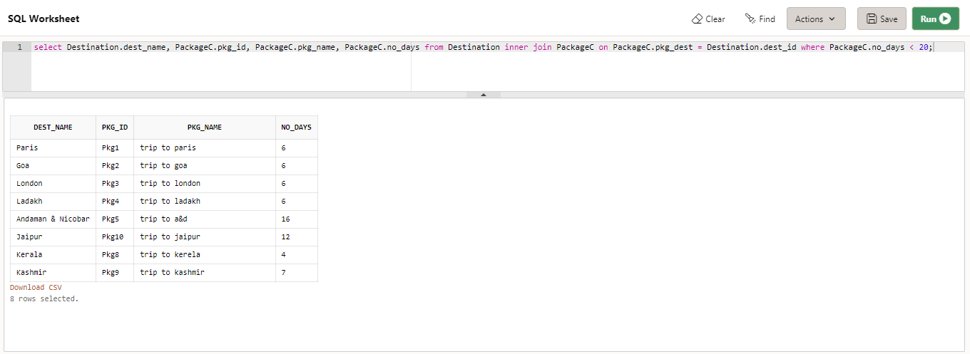

**List the details of all the packages under 40000:**

select pkg_id, pkg_name, pkg_dest, pkg_price from PackageC inner join Destination on PackageC.pkg_dest = Destination.dest_id where pkg_price < 40000;

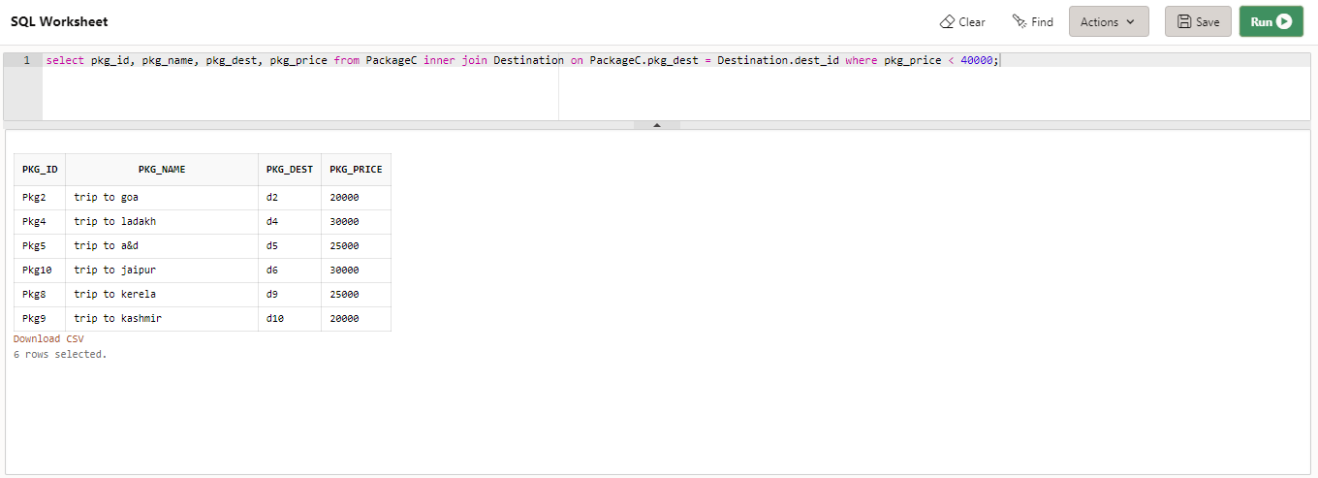

**The company has decided to give some discount to the customer who has a package greater than 20000 So, list all the details of customer whose package is more than 20000;**

select * from Customer where cust_id in (select customer from Booking inner join PackageC on PackageC.pkg_id = Booking.package_Taken where PackageC.pkg_price > 20000);

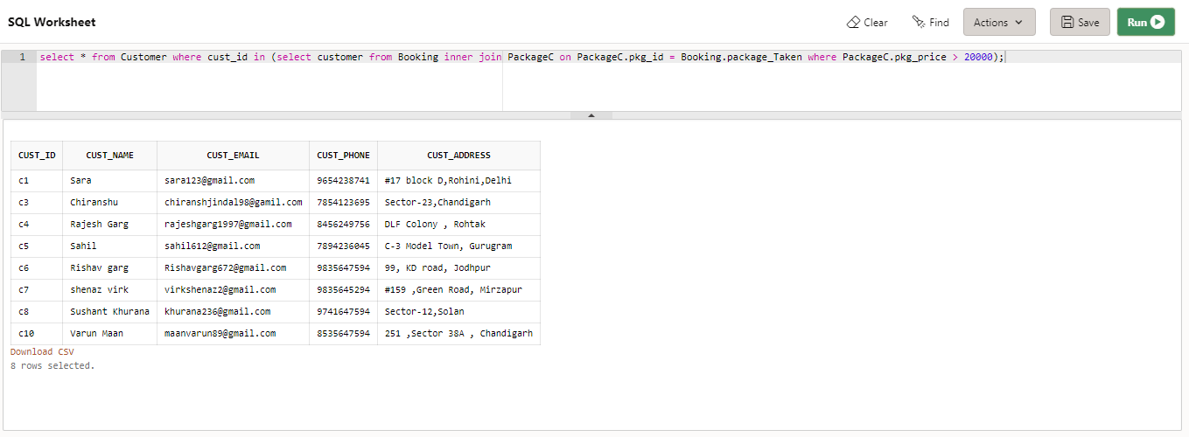

**Display details of staff whose salary of the staff is < 15000:**

select * from Staff where staff_r in (select sroll_id from StRoles where staff_sal < 15000);

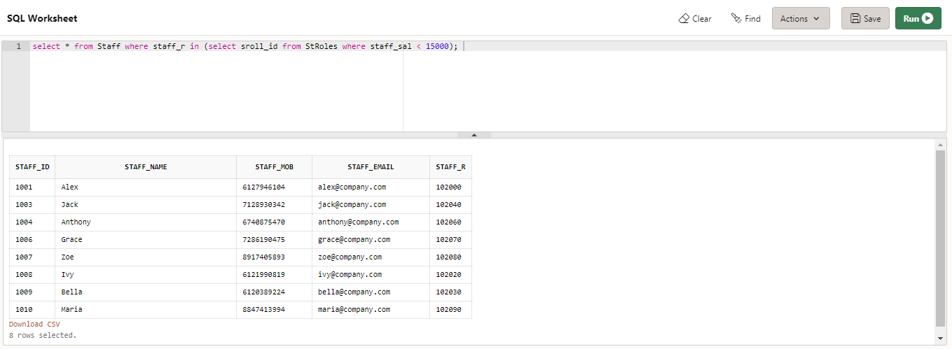

**Display all the packages along with the hotel and destination info:**

select PackageC.pkg_Name, PackageC.no_days, PackageC.pkg_price, Hotels.hot_Name, Destination.dest_name from PackageC inner join Hotels on PackageC.pkg_hotel = Hotels.hot_id inner join Destination on PackageC.pkg_dest = Destination.dest_id;

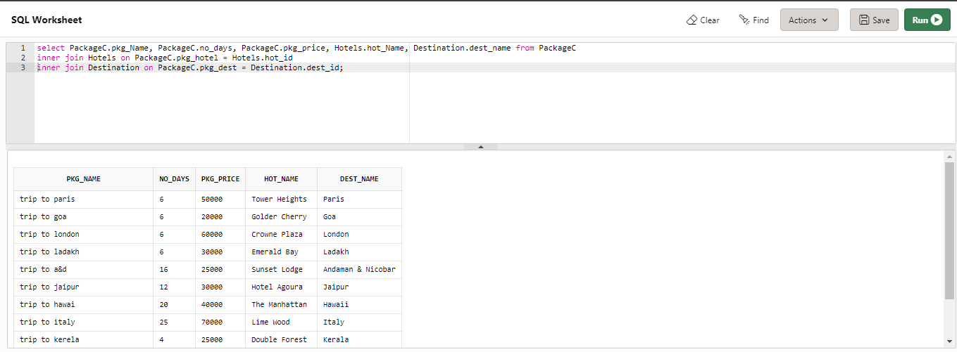

**Display all the international offers:**

PackageC.pkg_Name, PackageC.no_days, PackageC.pkg_price, Hotels.hot_Name, Destination.dest_name from PackageC inner join Hotels on PackageC.pkg_hotel = Hotels.hot_id inner join Destination on PackageC.pkg_dest = Destination.dest_id where Destination.dest_name in ('Paris', 'London', 'Hawaii', 'Italy');

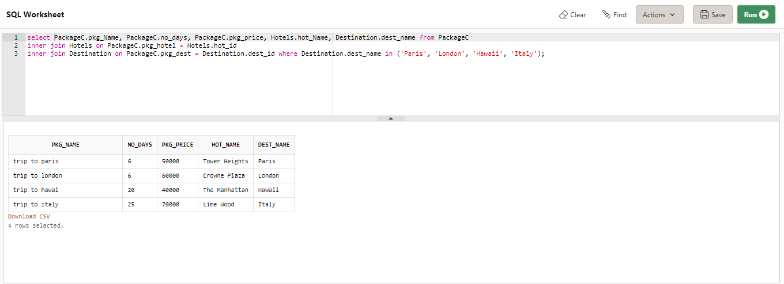

**Display the details of customers having mode_of_payment as cash:**

select * from Customer where cust_Id in (select customer from Booking where mode_of_payment = 'CASH');

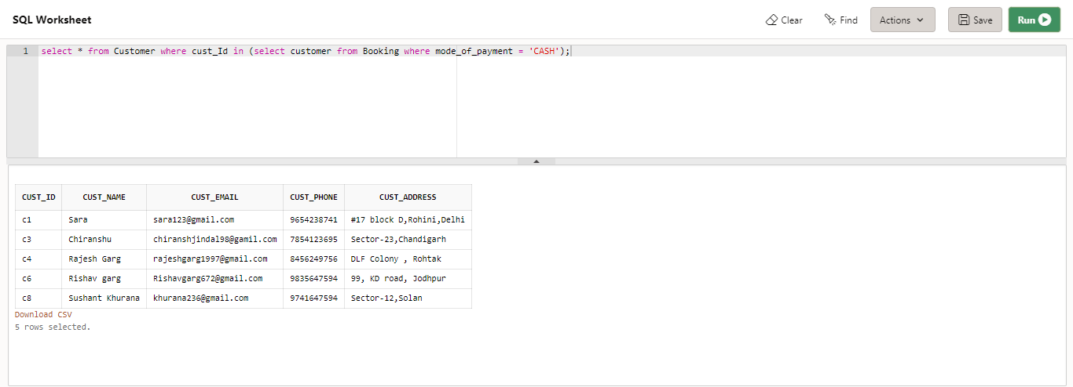

**Display the details of packages given by travel agent 'Jack':**

select PackageC.pkg_Name, PackageC.no_days, PackageC.pkg_price, Hotels.hot_Name, Destination.dest_name from PackageC inner join Hotels on PackageC.pkg_hotel = Hotels.hot_id inner join Destination on PackageC.pkg_dest = Destination.dest_id where pkg_id in (select packageGiven from givesPackeges where travel_agent in (select agent_id from Travel_Agent where agent_name = 'Jack'));

